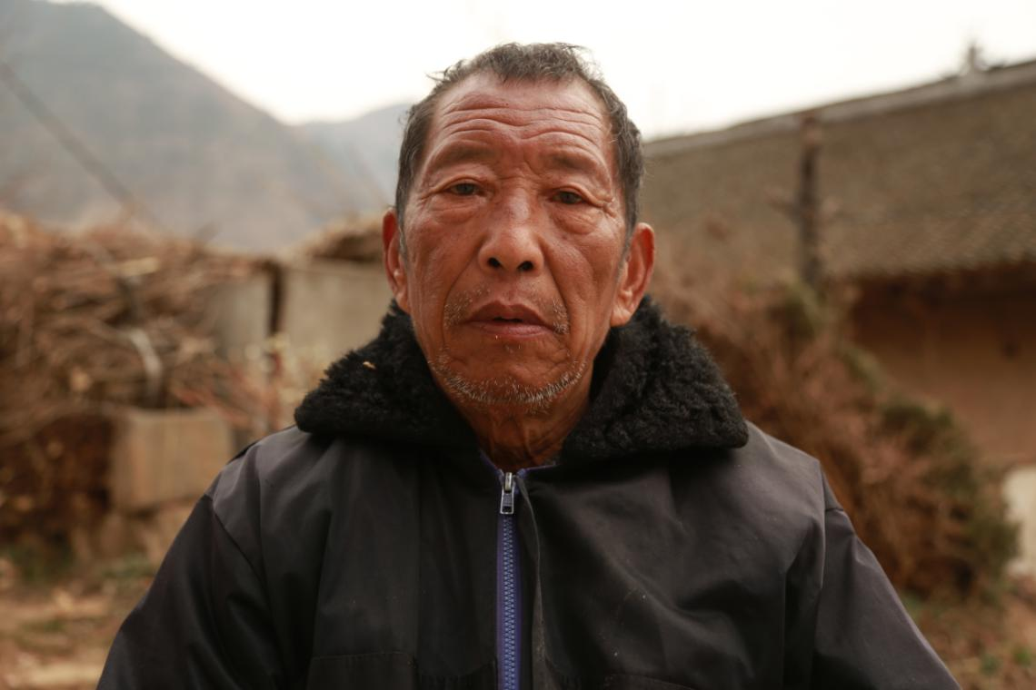

采访时间：2013年
Time: 2013
采访地点：陕西省湘子店村
Location: Xiangzidian Village, Shaanxi Province

被访人：杨五魁
Interviewee: Yang Wukui
出生年：1945
Birth: 1945
村子：陕西省湘子店村
Village: Xiangzidian Village, Shaanxi Province

采访人：胡涛
Interviewer: Hu Tao
出生年：1992
Birth: 1992
职业：纪录片工作者
Occupation: Documentary film maker

采访日记：
The interviewer’s notes:
这位爷爷是我的邻居，和家里人不怎么说话，平日里坐在房子的一角，一坐就是一天。我说要给他采访，他说他说不了，但是我还是把他请到我家院子里做采访。他得过脑梗吐字含混不清，问一句答一句。采访了一会儿，他家的狗叫了几声，他就不停地往家那个方向看，然后他就匆匆地起身回家了。前几日，他家里的养子训斥他不好好看家在村子里杨乱跑。
This grandpa is my neighbor. He doesn’t speak much with his families and often sit in the corner of his house all day long. When I asked to interview him, he said that he couldn’t speak, but I invited him to my yard to interview him nonetheless. Because he had cerebral infarction, his speech was vague. He wouldn’t say a word if I didn’t ask a question first. After a while, his dog barked, so he kept looking to the direction of his home. Then he hurried back home. A few days earlier, his adopted son scolded him for wondering around in the village without looking after the house.

采访正文：
Interview:
我：你能记得59年左右的事吗？
Me: Can you recall what happened in 1959?
杨五魁：记不清了。
Yang Wukui: Not clearly.
我：你现在多大年纪？
Me: How old are you?
杨五魁：68岁。
Yang Wukui: 68.
我：那时候苦得，你主要干啥？
Me: What did you do for the most part during the hard time?
杨五魁：修路。
Yang Wukui: Road construction.
我：主要吃啥？
Me: What did you eat mostly?
杨五魁：吃的包谷糊汤。
Yang Wukui: Corn gruel.
我：能吃饱吗？
Me: Could you eat until you were full?
杨五魁：吃不饱。
Yang Wukui: No.
我：那时候家里怎么样？几口人？
Me: How was your family back then? How many people were in it?
杨五魁：不好。我妈，我大，我兄弟，我，我妹子。
Yang Wukui: Not good. There were my mother, father, brother, sister, and I.
我：吃的啥？
Me: What did you eat?
杨五魁：哎呀，那说不成，吃的饭不是个饭。上坡挖野菜，都挖不到，吃的榆树皮。
Yang Wukui: Ah, it is a pity even speaking of it. We never had normal meal. Even potherbs on the hill were gone, so we had to eat elm barks.
我：咱村子没得人饿死？
Me: Nobody starved to death here in the village?
杨五魁：没得。
Yang Wukui: No.
我：吃大锅饭在哪里？
Me: Where did you eat “daguofan (the egalitarian great pot)”?
杨五魁：在狗娃那里，做活记工，啥都做，挖地锄草，给庄稼打药。
Yang Wukui: At Gouwa’s place. I worked to earn points. I did everything, plowing, weeding, spraying pesticide, etc.
我：那时候病了咋办？
Me: What could you do if you were ill back then?
杨五魁：看病没钱看，扛着病。我大饿死的。
Yang Wukui: You tried to tough it through since nobody had money to treat illness. My father starved to death.
我：你那时候没得记忆最深的？
Me: Was there anything particularly impressive to you?
杨五魁：没得，都忘了。
Yang Wukui: No. I forgot everything.
我：你那时候干活从几点到几点？
Me: How long did you work in a day at that time?
杨五魁：早上一明就起来，修水渠，就那河边的。
Yang Wukui: I started to work as the sun rises. I constructed canals near the river.
我：大炼钢铁时，是什么样的？
Me: What was the backyard furnace campaign like?
杨五魁：晚上加班砍树烧炭，山上有花梨树，柏树，冬青树。松树以后种的。以前坡上都没有树。
Yang Wukui: We worked overtime at night to cut trees and make them into charcoals. On the hill, there were rosewoods, cypresses and hollies. Before, there was no tree at all on the hill. Pines were planted afterwards.
我：你后来上山种树了？
Me: Did you go to plant trees on the hill?
杨五魁：种了。种的树都是小树苗。以前所有山都没得树。
Yang Wukui: Yes. I planted saplings. Before that there was no tree on the hill.
我：在公社吃大锅饭，吃的啥？
Me: What did you eat at People’s Commune canteen?
杨五魁：就是玉米糊汤。
Yang Wukui: Just corn gruel.
我：咱们这里遭水灾你记得吗？
Me: Do you remember the flood here?
杨五魁：都到这前面。咱这里都淹了，其他地方有淹死人了。涨水是晚上，咱们这里不要紧，特别后湾，都淹完了。
Yang Wukui: Here it flooded everything below that place. People were drowned elsewhere. It started at night. We were better off here, but Houwan was all flooded.
我：这个东远堡是几时开垦的？
Me: When was this Dongyuanpu reclaimed?
杨五魁：东远堡是个山包，我们把他铲平，土都堆在旁边，全大队的人都参与。
Yang Wukui: Dongyuanpu used to be a hill. We flattened it out and piled up dirt we dug out aside. The entire production brigade did it.
我：以前的事情你有记得清楚吗？
Me: Can you recall things in the past clearly?
杨五魁：记不清了，有六十多年了。
Yang Wukui: No. It has been more than sixty years.
我：那时候穿的啥？
Me: What did you wear at that time?
杨五魁：烂衣服，穿的鞋，是用草编的草鞋。过年吃的玉米糊汤，过年也响炮，也让敬神。
Yang Wukui: Shabby clothes. Shoes I worn were straw sandals. In the Chinese New Year, I ate corn gruel. In that occasion we set off firecrackers and pay tributes to gods as well.
我：那时候看病怎么样？
Me: How did you treat illness back then.
杨五魁：看不起，没钱看。
Yang Wukui: We didn’t, because we had no money.
我：你现在还种庄稼吗？
Me: Do you still farm now?
杨五魁：不种，院子边种菜地。做不了了，有病看了一回。跑不动，也做不了了。家里边也不孝顺。孙子孙女还可以。
Yang Wukui: No. I grow vegetables near the yard. I couldn’t farm anymore, since I had illness. Though I have treated it, I can no long run or work hard. My children are not filial, but grandchildren are better.
我：国家现在给你补助没？
Me: Do you receive subsides from the government?
杨五魁：补助，一个月55元，一年六百多，这个钱家里人拿着，没给我。
Yang Wukui: I receive a subside of 55 yuan per month. That is over six hundred yuan every year. My children have the money, not me.
我回啊，我回啊。
I must go home. Bye.

